Sonata BHD(2.5mm Balanced Output) firmware update instruction

1.Please plug Sonata BHD into the usb port of your computer. please don't forget to plug your headphones into sonata BHD first.

2. Please download and unzip it, then run de xxx.exe file. http://www.tempotec.com.cn//en/3-Support/index.htm
the firmware is at the bottom of this web page.

3.please do as following steps:

a. if this message box pops up, please click Yes.

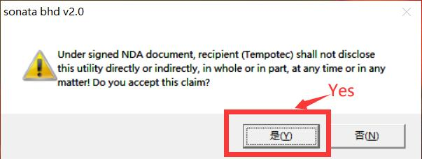

B, then fill in these two strings into the blanks, and click ”Write EEPROM”.

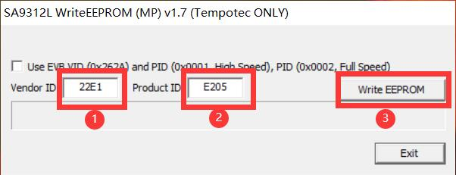
c. if the message box below shows up, please replug Sonata BHD and wait for 5 seconds, then click “Yes” to continue.
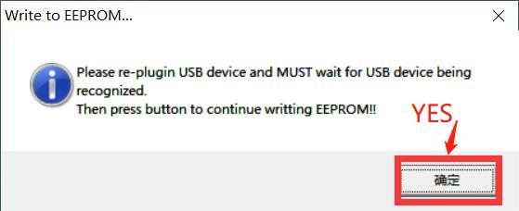
d. please wait for the update completed
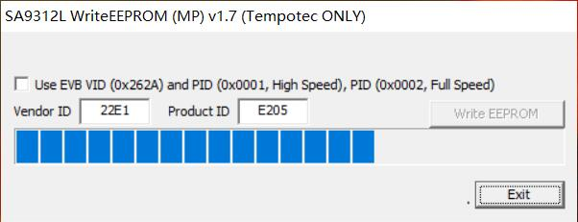
Then there is a message box as following picture shows, if update is successful.
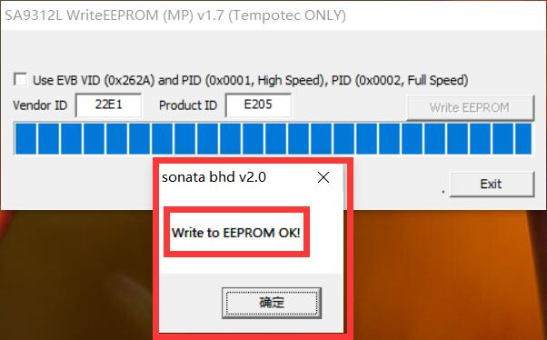
Note:
If the following message box is a popped up when you update firmware, Please fill “262A” into the first blank and ”920E” into the second blank. Please check the second picture below. Then start to update firmware as the third part above shows.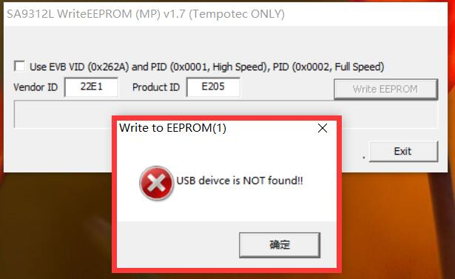

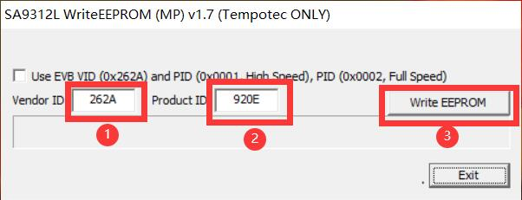

If the following message box is still popped up, please try to fill “262A” into the first blank and ”0001” into the second blank. Please check the last picture. Then start to update firmware as the third part above shows.
